NAME: K Yamini
REG NO: 192572181

Write a Prolog Program to implement Pattern Matching.
Aim:
To implement pattern matching in Prolog by comparing a given pattern with a list of values.
Algorithm:
- Start the program.
- Define a pattern as a list.
- Define the input list.
- Compare the pattern with the input list.
- Match each element one by one.
- If all elements match, return success.
- If any element does not match, return failure.
- Display the matching result.
- Stop the program.
Prolog program:
% EXPERIMENT 31
% Pattern Matching

% Pattern matching predicate
pattern_match([], []) :-
write('Pattern matched successfully.'),
nl.

pattern_match([H1|T1], [H2|T2]) :-
H1 = H2,
pattern_match(T1, T2).

% Main program
pattern_matching :-
Pattern = [a, b, c],
Input = [a, b, c],

write('Pattern: '),
write(Pattern),
nl,

write('Input: '),
write(Input),
nl,

pattern_match(Pattern, Input),
!.
Input:
In GNU Prolog, enter:
?- pattern_matching.
You can also test directly:
?- pattern_match([a,b,c], [a,b,c]).
Output :
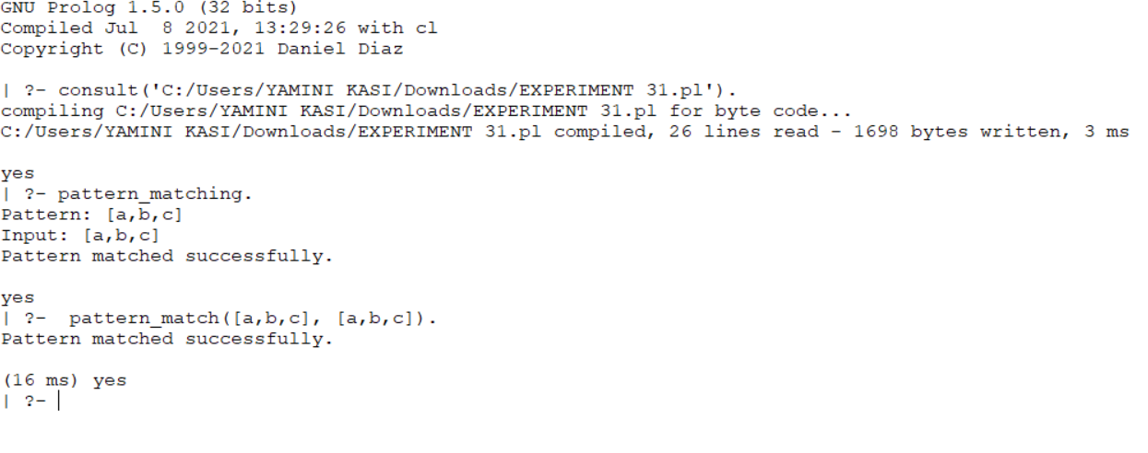
Result:
Thus, the Pattern Matching problem was successfully implemented in Prolog, and the given pattern was successfully matched with the input list.

